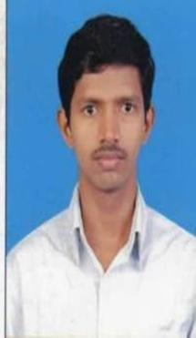

**K.VIJAYA KRISHNAN**

Certified Full Stack Web developer

Github Name: kvijayakrishnan

Linked In: VIJAY KRISHNAN

My portfolio: <https://imaginative-kringle-64c6da.netlify.app/>

E-mail: vijayakrishnankbv@yahoo.in

Mobile: +919629278809

**Objective:**

I search the position that will allow to improve my current programming skills, communication and team work skill. From this position, I also seek the opportunity to learn new skills for future use.

**Skills:**

* HTML5
* CSS 3
* JavaScript
* Bootstrap
* MUI
* React Js
* Node Js
* My Sql
* Mongo DB

**My sample Projects:**

Movie App

* Design and build the Movie App using with react, wrote the code readable, maintainable the code

Meme Page

* In this statically type web page build using only HTML, CSS, JS, with using a api calls, and looping the functions

Calculator

* In this App used to build in HTML, CSS, JS, with user friendly

**Declaration:**

I hereby declare that all above mentioned details are true to the best of my knowledge.

**(K. VIJAYA KRISHNAN)**